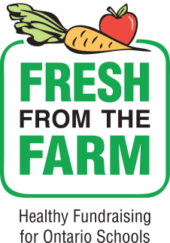

The William Burgess Parent Council is excited to announce a new fundraiser this fall!
Fresh from the Farm provides schools and students with a healthy fundraising opportunity by selling Ontario fruit and vegetables to the community, while supporting local farmers and the economy. The program also supports ongoing efforts to develop healthier learning environments within schools.
Students raise funds by selling bundles of fresh, Ontario-grown potatoes, onions, carrots, sweet potatoes and apples. Fresh from the Farm supports and integrates several Ontario government priorities, including Ontario’s Food and Nutrition Strategy, 2017, The School Food and Beverage Policy and the Local Food Act, 2013.
Fresh from the Farm achieves significant profit for their school while helping to create a more supportive nutrition environment. Students fundraise into early October with deliveries scheduled throughout November. Parent volunteers bundle produce the same day the Ontario grower delivers the product to the school. Fresh from the Farm provides an ideal opportunity for schools to introduce the topic of agri-food and healthy eating into the classroom.
Please see attached brochure and student order form. We ask that all order forms be returned to class teachers NO LATER than Friday October 12th. Order forms will not be accepted after this due date.
Understanding that not all families will be able to take part in this fundraiser, we would like to gather monetary donations to purchase extra produce and create “donation bundles”. These extra bundles will be distributed to our school families and community members in need.
If you wish, please indicate additional monetary donation:
$5.00 ______ $10.00 _____ $15.00 _____ $20.00_____ other amount ______

If you have any questions about this fundraiser please email us at williamburgessfundraising@gmail.com
Thank you for your support!
From the William Burgess Parent Council

